Doe; black with moonspots; blue eyes Wooly Dog Down Zoey DOB: 5-11-09

Parents | GrandParents | G-GrandParents | G-G-GParents | G-G-G-GParents
Enchanted Hill Toby  Chocolate cou claire  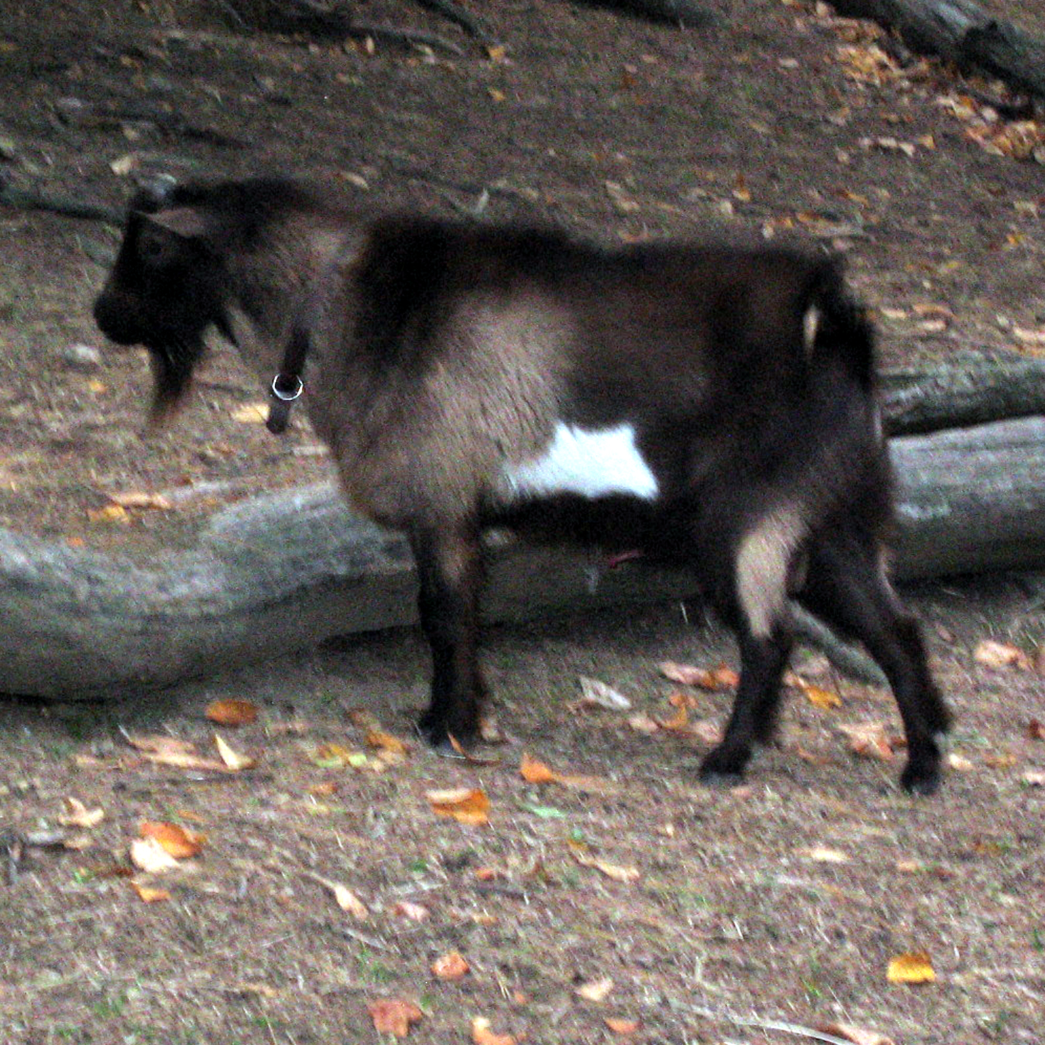 | Little Tot’s Estate Joe-Pye | Kaapio Acres KK Chief Justice | MCH Rosasharn Tom’s Keiki Kane | ARMCh Goodwood Tom Thumb+S
 |  |  |  | Rosharn’s Iki
 | Little Tot’s Estate Joe-Pye | Kaapio Acres KK Chief Justice | MCH Gay-Mor B Lacewing’s Parsley | MCH 4-Fun Bucky
 |  |  |  | Gay-Mor Kingpin’s Lacewing *D
 | Little Tot’s Estate Joe-Pye | Brush Creek Faithful | Willow Creek Macbeth | Willow Creek White Lie
 |  |  |  | Hayseed Lil’ Coconut
 | Little Tot’s Estate Joe-Pye | Brush Creek Faithful | MCH Buttin’ Heads Reason For Living | Creek Road Hudson
 |  |  |  | ARMCh BH Brytedal Veil 2*D
 | Enchanted Hill Mermaid | Enchanted Hill CC Wm F Buckley | Karim’s Little Owl | Woodhaven Farms Lonesome Blue
 |  |  |  | Lindsey Mika
 | Enchanted Hill Mermaid | Enchanted Hill CC Wm F Buckley | Enchanted Hill Lotus Blossom | Goodwood Merlin
 |  |  |  | Enchanted Hill Leprechaun
 | Enchanted Hill Mermaid | Enchanted Hill CC Tutu | Karim’s Little Owl | Woodhaven Farms Lonesome Blue
 |  |  |  | Lindsey Mika
 | Enchanted Hill Mermaid | Enchanted Hill CC Tutu | Enchanted Hill Lisa | Willows Razzle Dazzle
 |  |  |  | MCH Enchanted Hill Lily
Wooly Dog Down  Xs & Os  Black & white schwartzal;  20”Blue eyes  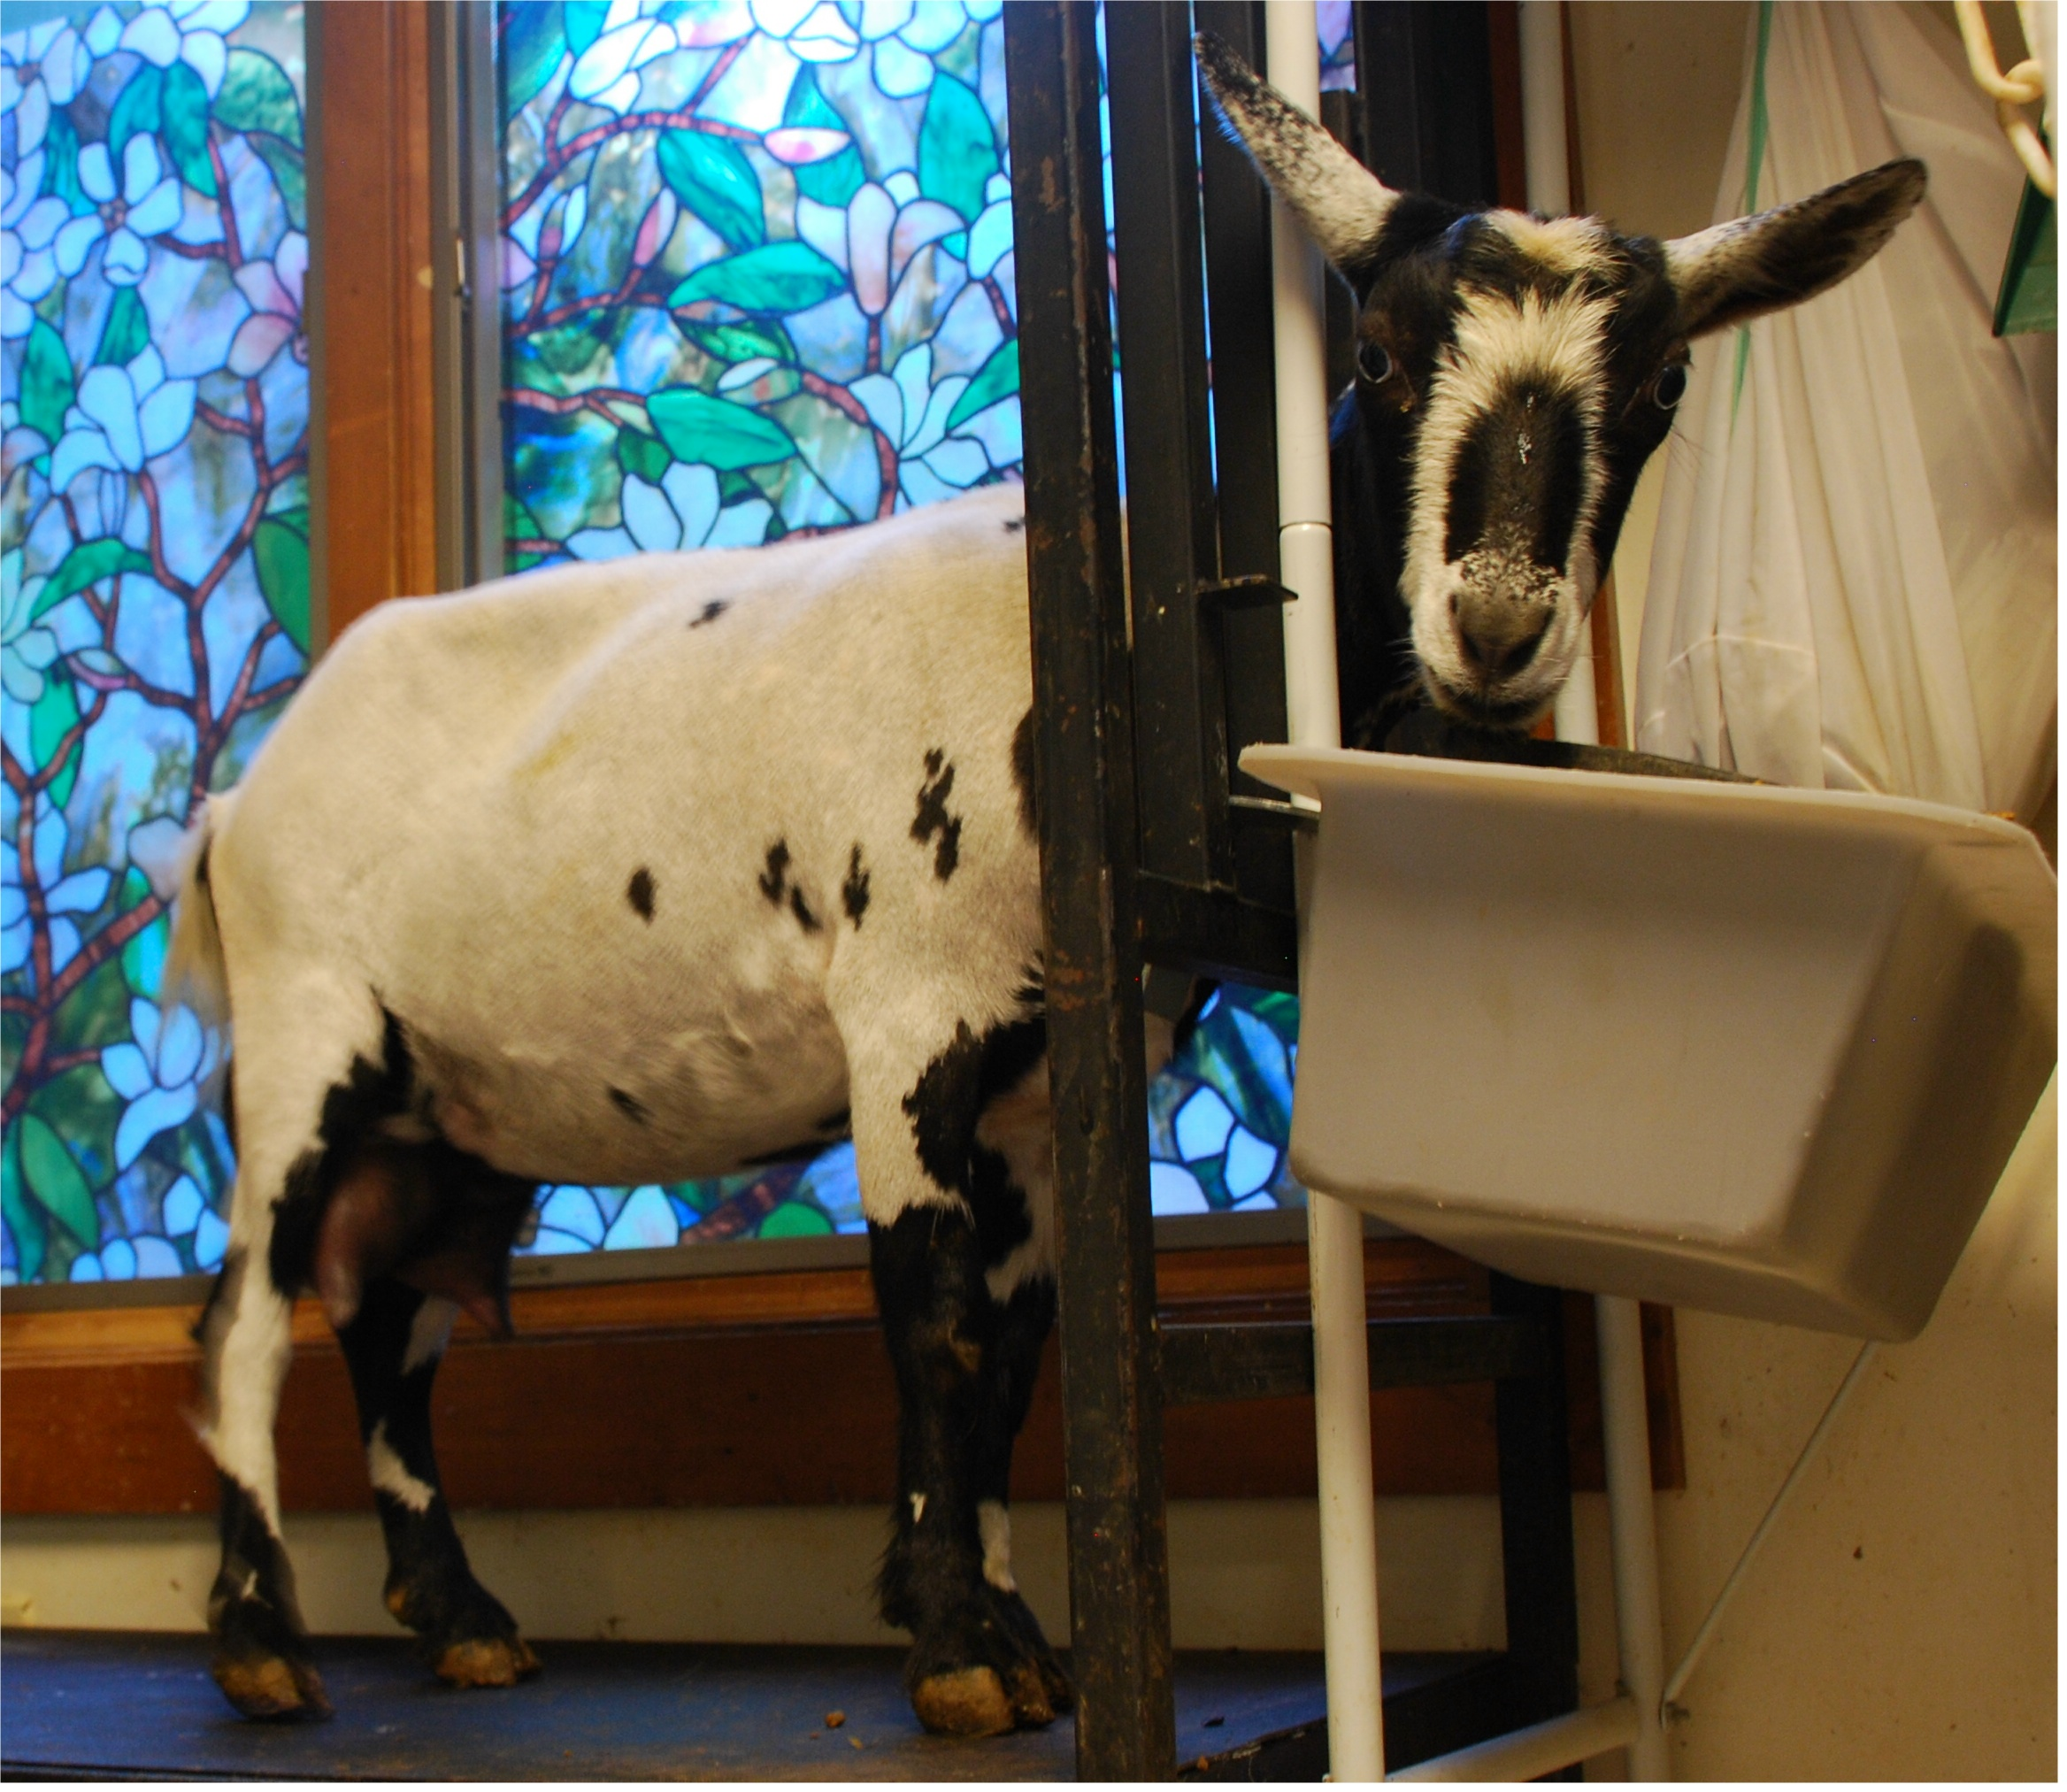 | Kids Corral CR WhisperWill  Black w/ white spots, polled; 22” | Flat Rocks Crescendo | PGCH/MCH Piddlin Acres  Blue Thunder +S VG 89.9  Black & white schwartzal; 20.5” | MCH GPZ Ali’s Tex
 |  |  |  | Woodhaven Farms Moondancer
 |  | Flat Rocks Crescendo | Piddlin Acres Alley Oops *D  Top Ten Milker in 1999 & 2000 | Jobi Toledo
 |  |  |  | Piddlin Acres Diamond Deb
 |  | Swanson Doemain Emma *D  Black w/white spots; 21”  2007 No. 1 AGS 1-day-test milker | Woodhaven Farms Hakuna Matata | Storybook Domino
 |  |  |  | Woodhaven Farms Snow White Doe
 |  |  | Woodhaven Farms PJ | Storybook Mali
 |  |  |  | Woodhaven Farms Tootsie
 | Wooly Dog Down Sapphire  Black & white schwartzal; 20”  Blue eyes | Wooly Dog Down Ringo Starr *S  Black/tan sundgau w/flashy spots  Improved dairy character & rear legs | Gay-Mor’s LT Mickey Rooney +*S  Black & white schwartzal; blue eyes | Gay-Mor’s T Blue Looneytoons*S
 |  |  |  | Munchranch E Nellie Backata*D
 |  |  | Gay-Mor Ad Lib’s Mosaic 3*D  Black; 20” | Goodwood Ad Lib
 |  |  |  | UF Parnells Freckles 2*D
 |  | Rosasharn’s Tina 2*D  Gold; 20” | ARMCh Goodwood Tom Thumb +*S  EX 91.7 2x Nat’l GCH Buck | ARMCH Goodwood Kauri Tree ++*S
 |  |  |  | Goodwood Guadalupe *D
 |  | Rosasharn’s Tina 2*D  Gold; 20” | ARMCh Stonewalls Little Luli *D | Brush Creek Shiloh
 |  |  |  | Stonewall’s Chocolate Anna

